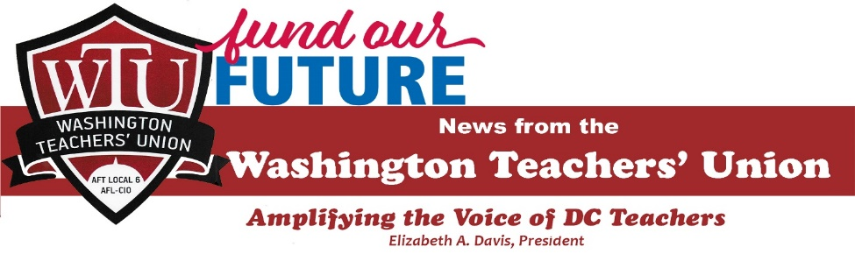

Join DCPS teachers and others who care about education in DC.
Rally to Fund Our Future
Thursday, April 25, 4 p.m.
Freedom Plaza
Pennsylvania Ave. NW—across from the Wilson Building

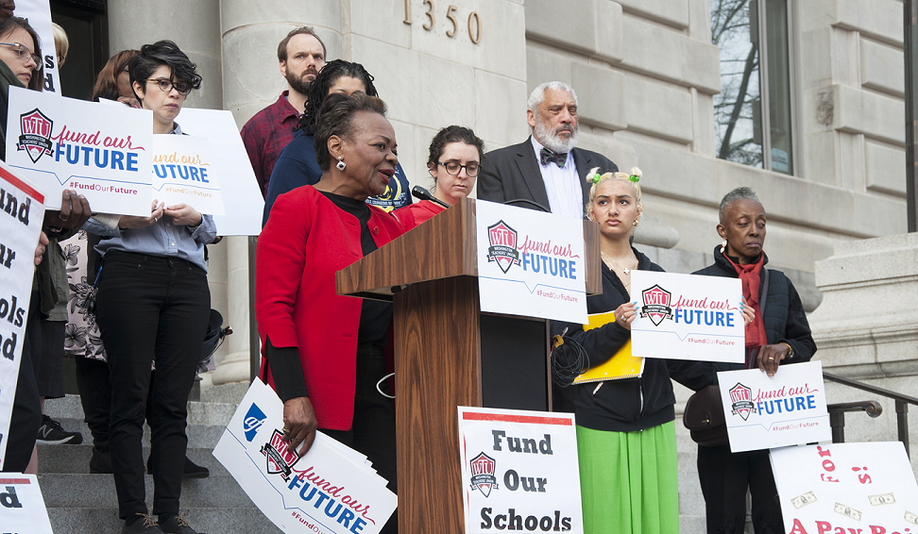
Let’s Tell Councilmembers They Must
Fully Fund Our Neighborhood Public Schools

Sign the Petition for Full Funding at http://bit.ly/WTUFOFPetition
Tell us if you can attend the rally by clicking here

